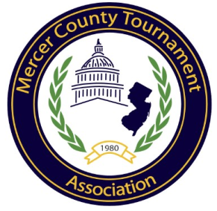

2017 MERCER COUNTY GIRLS SOCCER CHAMPIONSHIPS
GENERAL INFORMATION

Entry Forms:
All paperwork including seeding sheets completed by coaches as well as all results updated on NJSchoolSports.com by Friday, October 13 by 10:00 am. This year coaches will be able to seed the tournament how they see fit. Once all seeding sheets have been submitted a committee of AD’s will meet and seed the tournament using the coaches seeding sheets as well as win percentages. Win percentages will be taken from NJSchoolSports.com by that date and time. It is the coach and school’s responsibility to make sure that those records are accurate by the date and time and that their coaches seeding sheet is completed in time.

Please email Tripp Becker at trippbecker@hvrsd.org the following forms by Friday October 13th 10:00am
- Roster form (use same format as enclosed sample)
- Refusal form if you are not entering tournament. CVC Schools must have a win percentage below .300.
- Coaches seeding sheet
- Hopewell HS Certificate of Insurance
- Notre Dame HS Certificate of Insurance
- If in the finals both teams will need to complete certificate of insurance plus release forms for each player on the team
Entry Date:
All games played through Thursday, October 12, 2017 will count for seeding.
- Teams will be seeded on Friday, October 13, 2017. Game information will be sent via
e-mail on Friday, October 13, 2017 in the afternoon.

Games:
- All teams entering the tournament agree to make themselves available to the following game schedules.
  - On or Before Tuesday 10/17 – Play-In Games if needed
  - On or Before Thursday 10/19 – 1st Round Games at higher seeded team
  - On or Before Saturday 10/21 – 2nd Round Games at higher seeded team
    - Consolation Games @ higher seed
  - Monday 10/23 - Semi – Final Championship Bracket – games at 5:00 pm or 7:30 pm
    - Host schools could be Hopewell Valley or Notre Dame
  - Thursday 10/26 – Championship - 5:00 or 7:30pm
    - Game at The College of New Jersey
    - If Championship is postponed because of weather, games will be played Friday 10/27 at The College of New Jersey at 5:00 & 7:30
  - Each school is required to play two games.
> The Semi’s & Finals will have three officials.
- All Games will be played at the higher seeded team except for the semi-finals and finals of the championship bracket. Consolation games will be played at the higher seed with a 3:30 pm start (Consolation games can be played any day during MCT week as agreed upon by the competing schools.)
- Teams should follow bracket sheet closely.
- Specific instructions for championship game will be given at later date.
- Adjustments to this schedule may be made due to weather, state tournaments, and/or field availability.

Officials:
- Officials will be assigned by the soccer assignor, Michael Luciano. The home team will be responsible for paying both officials. In the semi’s, each school will split the cost of three officials. The FINALS will be paid by the MCT.

Games:
- All ties, including the up to the Finals, will be broken as determined by the NJSIAA state tournament rule. Two 10 minute over times, with the “golden goal” rule in effect, then a shoot-out if needed. If the finals are tied after two over time periods, the game will remain a tie and we will award Co-Champions.
- In the Finals, the higher seeded teams are required to bring four (size 5) soccer balls with the NFHS stamp of approval to be used as game balls.
- Each school must supply two ball runners for each side of their bench end of the field.
- Each School should bring one (1) administrator/faculty member to be responsible for their fans.
- Remind student body/ spectators that noise makers and banners (signs) are prohibited at ALL game sites.
- Higher seeded team is responsible to supply an athletic trainer for the game.
- Admission: Semi’s: $3 & $2 – Finals: ADULTS $5.00 - SENIORS AND STUDENTS $3.00

Refusal to Enter 2017 Mercer County Girls Soccer Tournament

___________________________________ ___________________________
(School) (Record CVC School Only)

We do not intend to enter the 2017 Mercer County Girls Soccer Tournament.

_____________________________ ______________________________
(Principals Signature) (Athletic Director’s Signature)

_____________________________
(Coaches Signature)

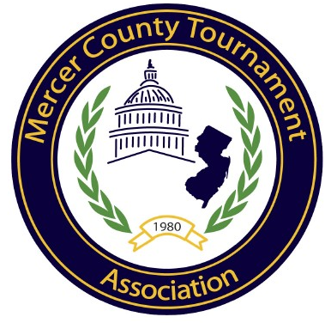

MERCER COUNTY TOURNAMENT
GIRLS SOCCER ROSTER

School Name:

Head Coach:

Assistant Coach:

ATHLETE NAME | POSITION | JERSEY NUMBER

